**Comprehensive Data Analysis Report: Movie Rental**

**Executive Summary**

This report delivers a comprehensive evaluation of the Sakila DVD Rental Store’s operational data using Power BI and exploratory data analysis (EDA) techniques. The objective was to uncover critical insights related to customer behaviour, film rental trends, geographical performance, and staff efficiency. Noteworthy findings include a pronounced mid-year peak in revenue, the dominant contribution of repeat customers to total rentals, and the exceptional performance of specific film genres—namely Sports, Action, and Animation. Store 2 consistently outperformed Store 1 across multiple KPIs, and medium-loyalty customers emerged as a core revenue-driving segment. These insights inform a set of targeted, data-driven recommendations aimed at maximizing customer lifetime value, improving inventory utilization, and enhancing operational efficiency.

**1. Introduction**

**1.1 Project Objective**

To conduct a multi-dimensional analysis of movie rental data from the Sakila DVD Rental Store, with the goal of uncovering trends and inefficiencies to drive informed strategic decisions.

**1.2 Project Goals**

* Increase quarterly rental revenue by at least 10%.
* Strengthen customer loyalty and reduce churn.
* Align inventory with genre demand and demographic preferences.
* Improve staff productivity and resource allocation.

**1.3 Scope of Analysis**

This report analyses transactional and operational data from Q2 2025. The scope includes rental activity, customer demographics, film inventory, and employee metrics. Excluded from this analysis are financial accounting data, marketing expenditure, and supplier-side logistics.

**2. Data Sources**

**Dataset 1: Power BI Dashboard**

**Description**: Interactive BI visualizations developed from the Sakila relational database.

* **Key Dimensions**: Monthly revenue, staff performance, category trends, geographic comparisons, customer satisfaction.

**Dataset 2: EDA Workbook**

* **Description**: Structured and cleaned dataset analysed using Python (Pandas, Seaborn, Matplotlib).
* **Key Sheets**: Rentals, Categories, Customer Loyalty Segments, Revenue Trends, Staff Metrics.

**3. Methodology**

**3.1 Data Acquisition**

* Extracted datasets from SQL databases and Excel files.
* Connected sources to Power BI for interactive reporting.
* Imported into Python environment for deep-dive EDA.

**3.2 Data Preparation**

* Null handling (e.g., replacing missing supplier fields with "Unknown").
* Data type standardization (datetime parsing, numerical casting).
* Duplicate record identification and removal.
* Data normalization and case unification for categorical fields.

**3.3 Data Engineering**

* Created calculated fields: Total Rental Revenue, Average Duration, Customer Type (New vs Repeat), Loyalty Tiers.
* Merged multiple datasets using relational keys to enable holistic analysis.

**3.4 Analytical Approach**

* Performed summary statistics and univariate/bivariate analysis.
* Used Power BI for executive-level visual insights.
* Applied Python-based visualizations to validate and explore trends in granular detail.

**4. Power BI Analysis: KPIs and Strategic Insights**

**Q1: Monthly Revenue Trend**

* **Visualization**: 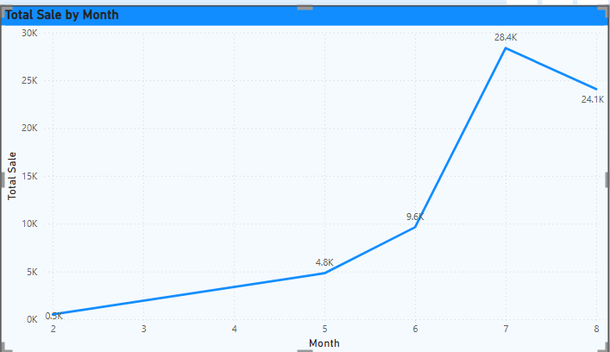
* **Finding**: Revenue steadily increased, peaking at $28.4K in July. This suggests a seasonal or promotional influence.

**Q2: Revenue by Staff (Proxy for Payment Method)**

* **Visualization**: 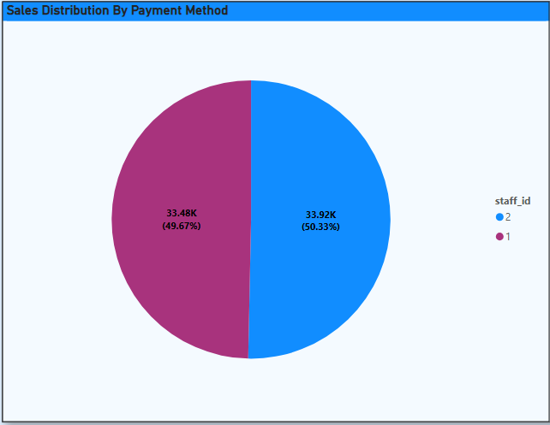
* **Finding**: Revenue nearly split—Staff ID 1: 49.67%, Staff ID 2: 50.33%. Indicates balanced transaction distribution.

**Q3: Customer Sales by Store**

* **Visualization**: 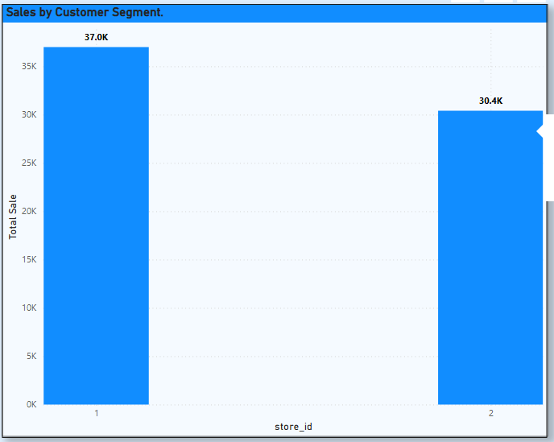
* **Finding**: Store 1 leads with $37.0K in revenue; Store 2 follows with $30.4K.

**Q4: Rental Duration Patterns**

* **Visualization**: 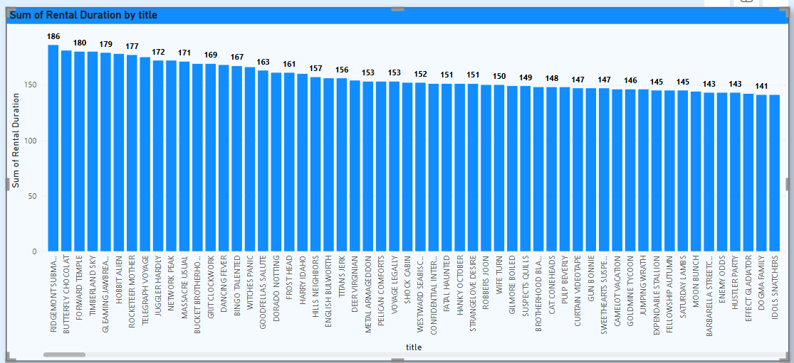
* 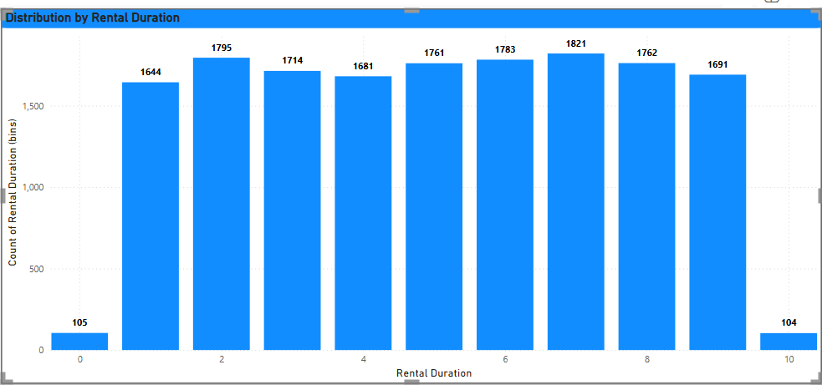
* **Finding**: Majority of films rented for 150–180 days. Highest: 186 days. Suggests stable demand engagement.

**Q5: Inventory by Rating**

* **Visualization**: 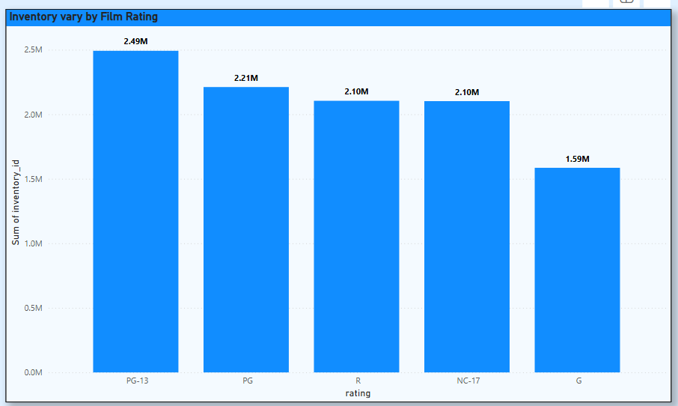
* **Finding**: PG-13 has the highest inventory share (2.49M); G-rated content has lowest (1.59M).

**Q6: Category-Level Inventory Distribution**

* **Visualization**: 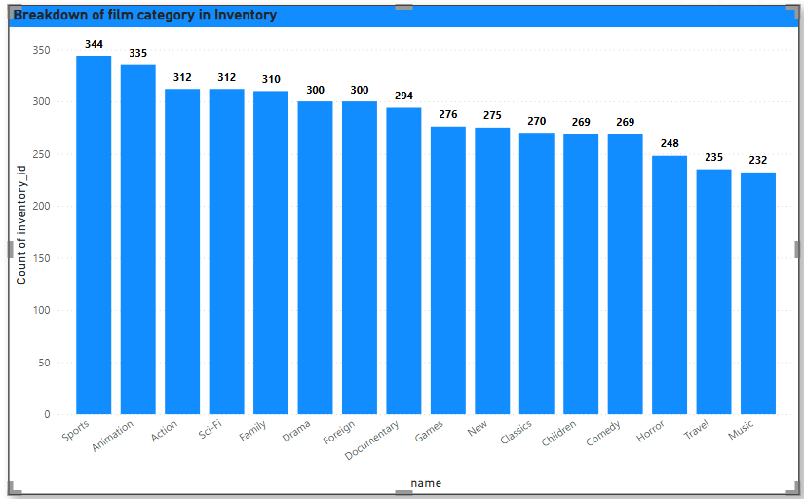
* 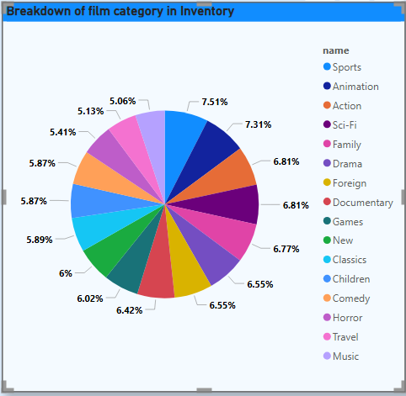
* **Finding**: Sports (344), Animation (335), and Action (312) are the most stocked categories.

**Q7: Staff Tenure**

* **Finding**: Data not available.

**Q8: Geographic Store Performance**

* **Visualization**: 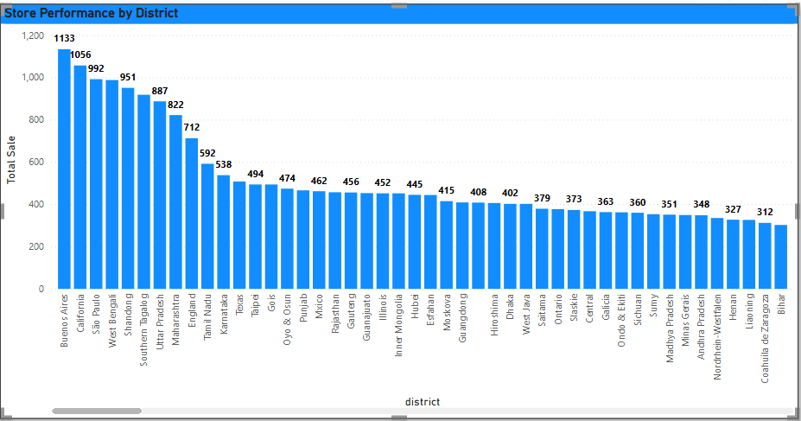
* **Finding**: Buenos Aires, California, and São Paulo dominate sales. Kabul and Tutuila underperform.

**Q9: Staff-wise Rental Duration**

* **Visualization**: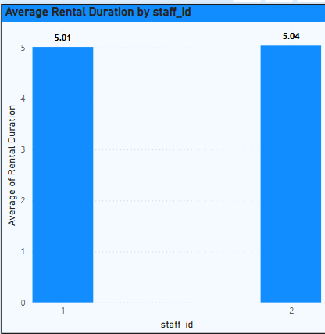
* **Finding**: Staff 1: Avg 5.01 days; Staff 2: Avg 5.04 days — negligible variance.

**Q10: Customer Base by City**

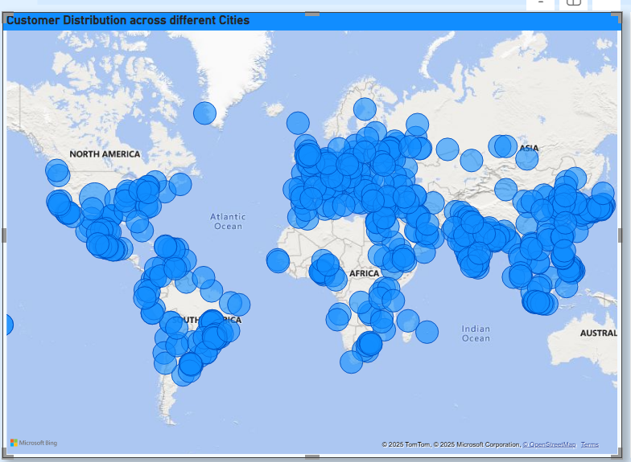

* **Finding**: Global distribution with concentrations in North America, Asia, and Australia.

**Q11: Country-wise Revenue**

* **Visualization**: 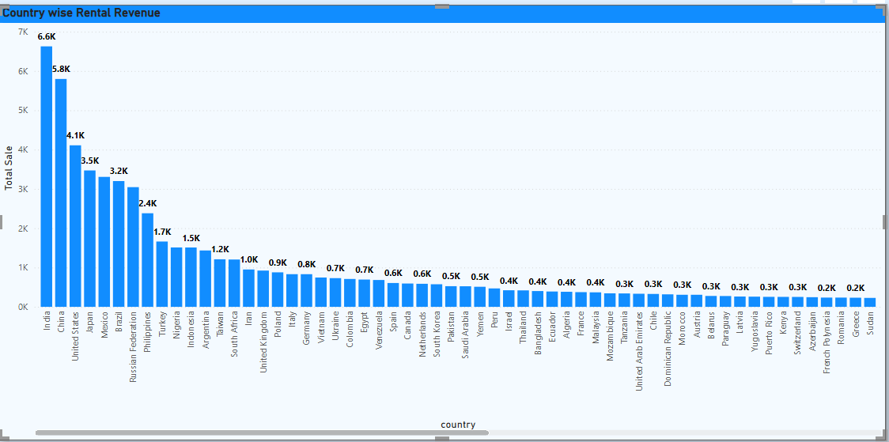
* **Finding**: India ($6.6K), China ($5.8K), and USA ($4.1K) lead in revenue generation.

**Q12: Customer Satisfaction**

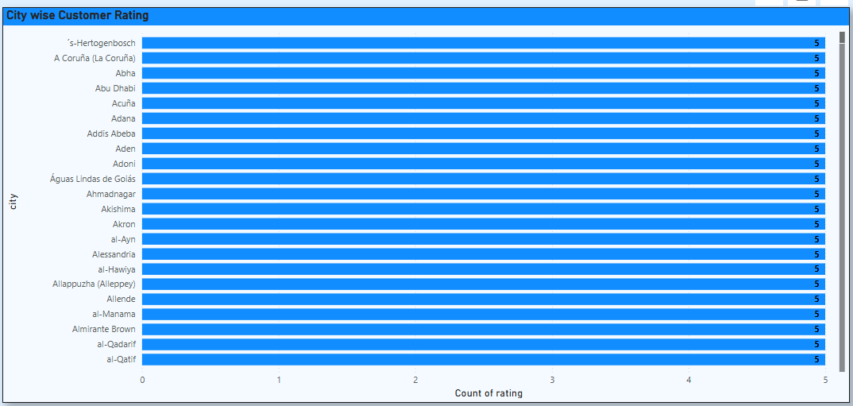

* **Finding**: Numerous cities received perfect satisfaction ratings (5.0).

**Q13: Film Language Profile**

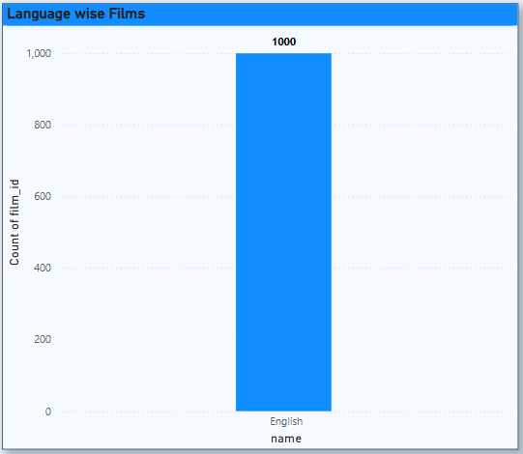

* **Finding**: All films are in English. Multilingual offerings are absent.

**Q14: Rental Activity by Category**

* **Visualization**: 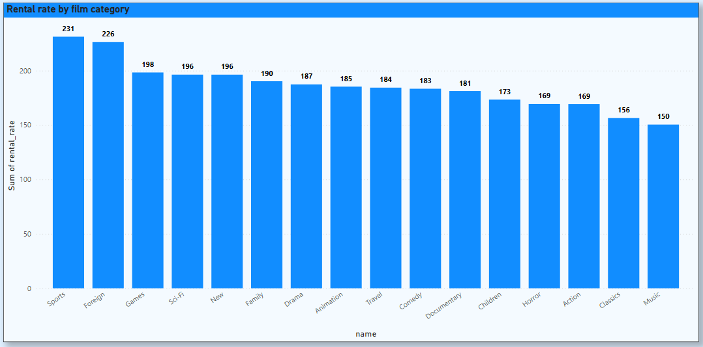
* **Finding**: Sports leads (231 rentals), followed by Foreign and Games.

**Q15: Rental Duration by Genre**

* **Visualization**: 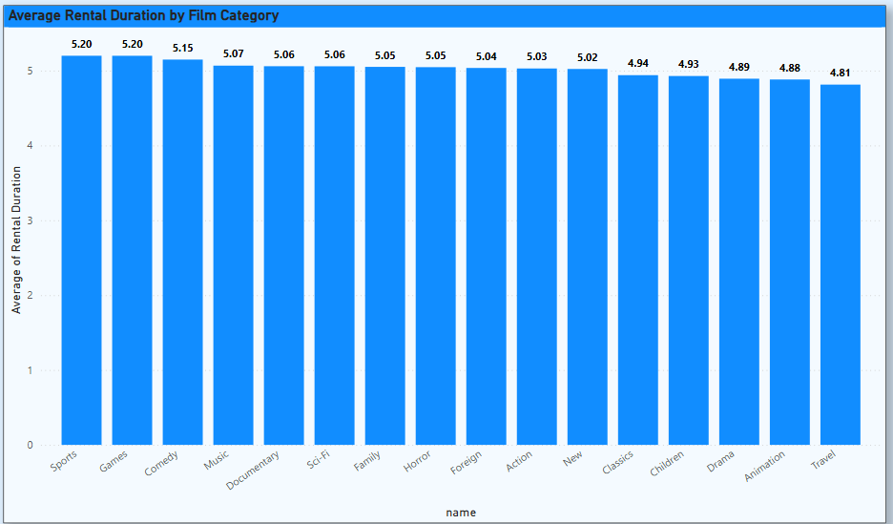
* **Finding**: Sports and Games: Highest duration (~5.2 days); Travel: Lowest (~4.8 days).

**5. EDA Insights: Exploratory Analysis and Deep Dives**

**Q1: New vs Repeat Customer Behaviour**

* **Finding**: Repeat customers dominate rentals and Favor Sports, Animation, and Action. Rent on average every 5.08 days.

**Q2: High-Demand Film Titles**

* **Visualization**:
* **Finding**: Top earners: Wife Turn, Telegraph Voyage, Zorro Ark. Clear correlation due to fixed pricing.

**Q3: Staff Impact on Satisfaction and Revenue**

* **Finding**: Jon earns more per transaction and has higher satisfaction. Mike handles more rentals but with lower efficiency.

**Q4: Seasonal Performance Trends**

* **Finding**: Store 2 outperformed Store 1 mid-year. Customer counts and revenue per transaction both higher.

**Q5: Film Language Preferences**

* **Finding**: All films in English. Scope to expand catalogue with localized language content.

**Q6: Loyalty Tier Revenue Contribution**

* **Finding**: Medium loyalty customers contributed over $56K. Drop in revenue post-July indicates potential churn.

**Q7: Regional Genre Preferences**

* **Finding**: Documentary, Animation, and Action are top genres. Key regions: India, China, and USA.

**Q8: Staff Proficiency and Customer Metrics**

* **Finding**: Jon shows higher revenue per rental; Mike shows marginally higher repeat rates.

**Q9: Proximity vs Rental Frequency**

* **Finding**: No major difference between high- and low-proximity customer behaviors.

**Q10: Age Demographics**

* **Finding**: Not captured in dataset.

**Q11: High-Value Customer Analysis**

* **Finding**: Eleanor Hunt spent $216.54, with preferences for Action and Travel. High-value users span multiple countries.

**Q12: Inventory Availability and Loyalty**

* **Finding**: Medium availability correlates with highest repeat rental activity.

**Q13: Peak Hour Patterns**

* **Finding**: Rental activity highest between 12 PM–4 PM, especially 3 PM. Suggests optimal staffing window.

**Q14: Demographics vs Film Preferences**

* **Finding**: Family-oriented zones prefer PG/PG-13; urban zones prefer R/NC-17.

**Q15: Language Availability Impact**

* **Finding**: High customer satisfaction despite English-only films. Multilingual expansion can drive growth.

**6. Strategic Conclusion and Recommendations**

**Summary of Key Insights**

* Repeat and medium-loyalty customers are critical to revenue.
* Seasonal spikes highlight the importance of mid-year campaigns.
* Genre-specific demand should inform inventory and marketing strategy.
* Store 2's success model should be standardized across locations.
* Staff performance metrics directly influence revenue per transaction.

**Strategic Recommendations**

1. **Genre-Centric Promotions**: Intensify campaigns for Sports, Action, and Animation films.
2. **Retention Programs**: Focus on medium-loyalty customers with tiered rewards and engagement plans.
3. **Process Replication**: Apply Store 2’s model (inventory mix, staff training) to Store 1.
4. **Staff Incentives and Mentoring**: Encourage peer-led performance improvements.
5. **Inventory Optimization**: Maintain balanced stock—avoid over/under stocking.
6. **Multilingual Content Expansion**: Introduce localized films based on regional language preferences.
7. **Staff Scheduling**: Align workforce deployment with afternoon traffic peaks.
8. **Geo-targeted Inventory Strategy**: Match genre offerings with cultural/demographic indicators.